**Unit I GATE Questions**

**Question 1 GATE CS 2012**

What is the minimal form of the Karnaugh map shown below? Assume that X denotes a don’t care term.

[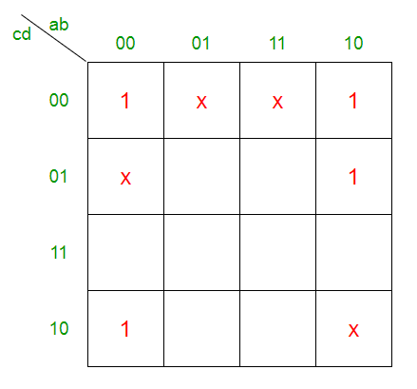](https://media.geeksforgeeks.org/wp-content/uploads/q28_2012.png)

**(A)** b’d’  
**(B)** b’d’ + b’c’  
**(C)** b’d’ + a’b’c’d’  
**(D)** b’d’ + b’c’ + c’d’  
  
**Answer:** **(B)**  
  
**Explanation:** There are two prime implicants in the following K-Map-  
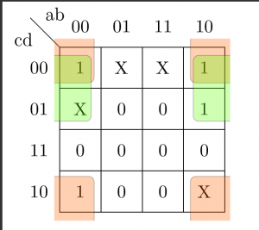  
Prime Implicant higlighted in Green =   
Prime Implicant higlighted in Orange =   
So the Boolean expression is-

Therefore option (B) is correct.

**Question 2** [GATE CS 2012](https://www.geeksforgeeks.org/gate-quiz-gq/gate-2012-gq/)

[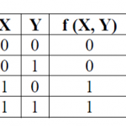](http://www.geeksforgeeks.org/wp-content/uploads/gq/2013/11/truthtable.png)

The truth table represents the Boolean function

|  |  |
| --- | --- |
| A | X |
| B | X+Y |
| C | X xor Y |
| D | Y |

**Answer:** **(A)**  
  
**Explanation:** The value of f(X, Y) is same as X for all input pairs.

We see from truth table –

Column x= f(x,y)

So , f(x,y)=x

Ans is (A) part.

|  |
| --- |
| **Question 3 GATE | GATE CS 2011** |

The simplified SOP (Sum Of Product) form of the boolean expression (P + Q' + R'). (P + Q' + R) . (P + Q + R') is

|  |  |
| --- | --- |
| A | (P'.Q + R') |
| B | (P + Q'.R') |
| C | (P'.Q + R) |
| D | (P.Q + R) |

**Answer:** **(B)**  
  
**Explanation:** See following :  
(P+Q’+R’).(P+Q’+R).(P+Q+R’) =   
gate2011A24  
From the K-map, POS form is :  
P + Q’.R’

|  |
| --- |
| **Question 4 GATE | GATE CS 2010** |

The minterm expansion of f(P, Q, R) = PQ + QR' + PR' is

|  |  |
| --- | --- |
| A | m2 + m4 + m6 + m7 |
| B | m0 + m1 + m3 + m5 |
| C | m0 + m1 + m6 + m7 |
| D | m2 + m3 + m4 + m5 |

**Answer:** **(A) Explanation:**  
  
[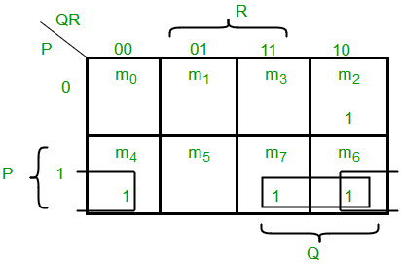](https://www.geeksforgeeks.org/wp-content/uploads/GATE_CS_2010_Question_6.jpg)

# Question 5: ISRO | ISRO CS 2015

The boolean expression AB + AB’+ A’C + AC is independent of the boolean variable  
**(A)** A  
**(B)** B  
**(C)** C  
**(D)** None of these  
  
  
**Answer:** **(B)**  
  
**Explanation:**

AB + AB' + A'C + AC

= A(B + B') + C(A + A')

= A + C(/pre)

As the expression is independent of 'B', option (B) is correct.

**Question 6 : GATE CS 2012**

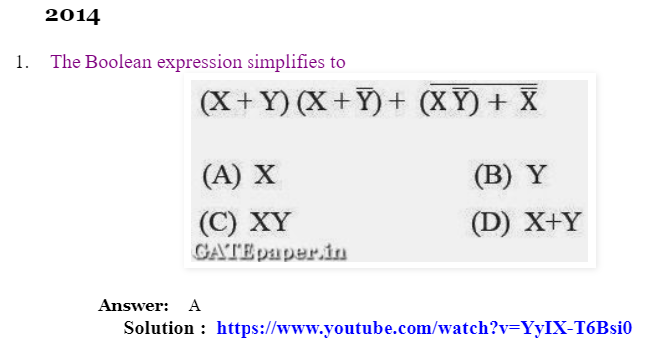

**Question 7 : GATE CS 2007**

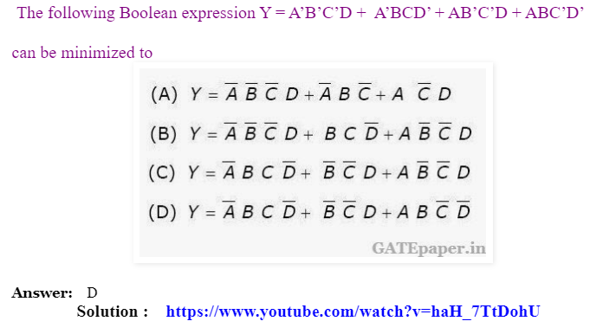

**Solution:** 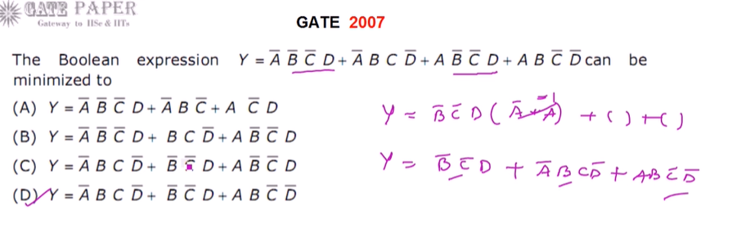

**Question 8 : GATE CS 2005**

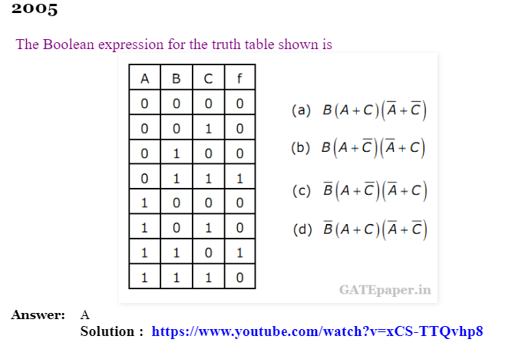

**Solution:** 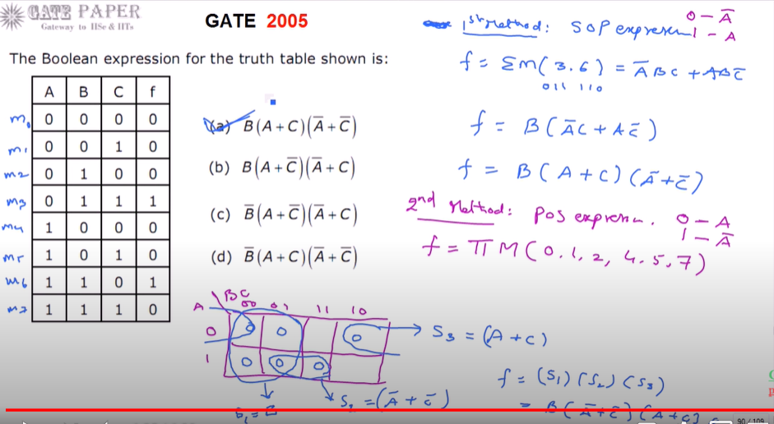

**Question 9 : GATE CS 2007** 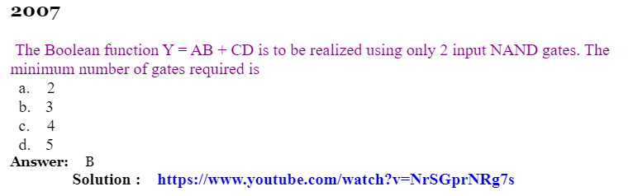Solution:

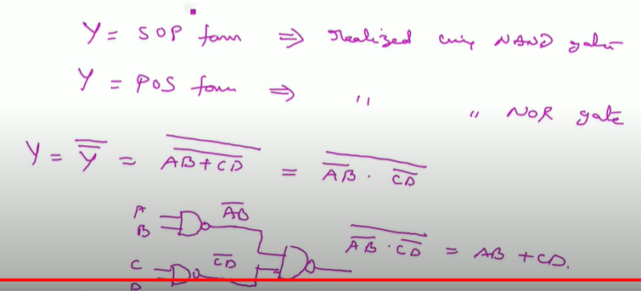

**Question 10 : GATE CS 1997**

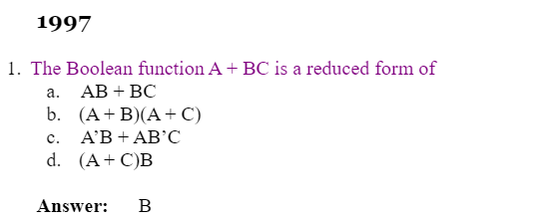

**Solution:**

